CARLTON LE MOORLAND

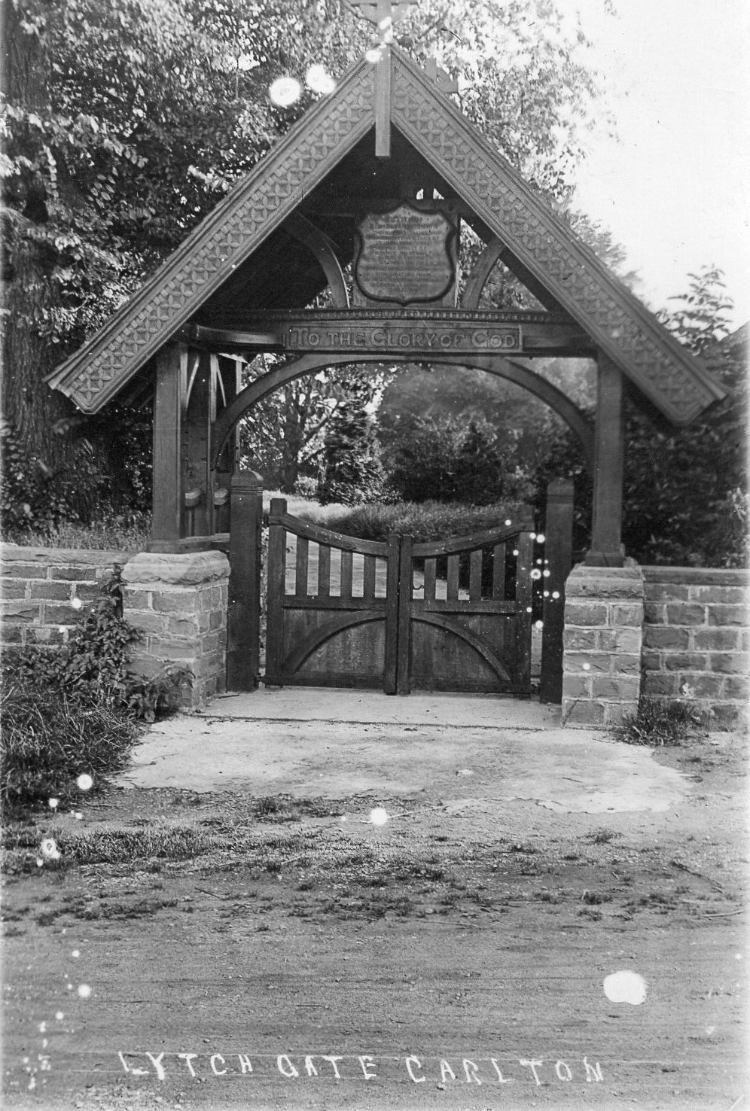

LYCHGATE WAR MEMORIAL
CARLTON LE MOORLAND LYCHGATE
In 1914, at the start of the Great War, many people, both men and women, heeded the call to arms to serve their country; our village was no exception. With its young men joining throngs of others around the country to sign up for military duties, a considerable strain would have been placed on the local workforce. In 1911, the population of the village was only some 300 souls with 24 young men volunteering to serve, seven of whom sadly were never to return. Details of all these young men are recorded at the end of this account.
The Annual Parish Meeting in 1919 was chaired by Mr William Edward Brocklebank, whose son Geoffrey was killed at Flanders in 1917. The minutes for this meeting gave the following short record, “It was agreed that a Lychgate would be erected as a memorial to those who lost their lives in the first World War.” There is no apparent record as to how the cost of the Lychgate was funded; perhaps William Brocklebank together with his brother, Joseph, funded the memorial jointly, both brothers having lost sons in the conflict. Joseph’s son, also named Joseph, had been killed whilst in transit to Gallipoli.
The Diocesan Board granted a faculty for the erection of the Lychgate in September of the following year, with brass plaques in the shape of shields listing the names of those who had served and those who had lost their lives. Also inside St Mary’s Church, on the south side of the Nave, there is a brass plate dedicated to the memory of Geoffrey Brocklebank.
The Sleaford Journal and Lincolnshire Chronicle recorded, in October, 1920, the unveiling of the lychgate (built of old English oak at a cost of £174 by Messrs. J & T Pask of Stapleford) by Major Harrison R.E. The service was taken by the Rev. Dolphin with a lesson being read by the Rev. Johnson, the Wesleyan minister.
Tragically, World War II claimed two further local men, F. R. Spratt and D. Bentley, whose names were later added to the memorial.
Over the years, a number of substantial repairs to the Lychgate have taken place, including the replacement of the original brass plaques. In June 2013, concerns were raised by the Church Wardens with the Parish Council, which has responsibility for the upkeep of the Lychgate, as to its deteriorating condition. The Council obtained quotes for the necessary work to be carried out and made an application for a grant from the Heritage Lottery fund, which was approved in 2014.
GEORGE BIRKETT was born in 1894 in Carlton le Moorland, the son of Henry, a general agricultural labourer (b. 1842, Swinderby) and Millicent (b. 1850 Bassingham). George had three sisters, Sarah b. 1881, Jane b. 1889, and Mary b. 1891. There were two brothers, William Henry b. 1884 and John b. 1886. All George’s siblings were born in the village. George was killed in action at Flanders on 27 September 1918. His brother, William Henry, was killed at Flanders also, in September of the previous year. George had enlisted at Newark, where he was then residing, as a Private in the 1st Battalion, Royal Scots Fusiliers (Regimental No. 201286).
WILLIAM HENRY BIRKETT was born in 1884 in Carlton le Moorland, the elder brother of George. William enlisted in Lincoln as a Private in the Durham Light Infantry (Regimental No. 42510). He was killed in action at Flanders on 25 September, 1917, a year and two days before his brother George. The family home was 4 Church Lane, Carlton le Moorland, adjacent to the footpath from St Mary’s Church to the High Street. William was buried in the Heninel Communal Cemetery at Heninel, Departement du Pas-de-Calais, France. (Plot E15)
GEOFFREY BROCKLEBANK was born in 1898 in Carlton le Moorland, the youngest son of William Edward, a farmer (b. 1857 Carlton le Moorland) and Mary (b. 1857, South Carlton). Geoffrey enlisted at the age of only 16, as a Private in the 9th Battalion of the Royal Fusiliers (City of London Regiment – Regimental No. 52909). He was killed in action at Flanders on 28th February 1917. He was buried at the Fauborg-d’Amiens Cemetery, Arras, Nord Pas-de-Calais, France. This branch of the Brocklebank family lived at Brocklebank Farm, Jerry Lane (now known as the Old Manor House, Manor Lane). William Edward and his wife Mary had six other children, who were all born in the village, Mary Ethel b. 1888, Carwell b. 1889, Margaret b. 1892, May b. 1895, William Edgar . 1896 and Eleanor b. 1902. William Edgar also served his country in the Great War as a Trooper in the Lincolnshire Yeomanry. The 1911 Census shows Geoffrey aged 13 years, a boarder at the Magnus School, Newark. There is a brass memorial to Geoffrey in St Mary’s Church, on the south side of the nave.
JOSEPH HUGH TURNER BROCKLEBANK was born in 1891 in Carlton le Moorland, the only son of Joseph, a farmer, b.1860, Carlton le Moorland, and his wife, Mary E. b. 1863 Ulceby, Lincolnshire. Joseph enlisted in the Lincolnshire Yeomanry, Regimental No. 1834, later becoming a member of the Household Cavalry and Cavalry of The Line, including Yeomanry and Imperial Camel Corps. He was killed by shell fire on 3 November 1915, on active service whilst in transit aboard HMS Mercian in the Mediterranean en route to Gallipoli and was buried at sea (this was witnessed by Robert Green, a grocer of Bassingham). Joseph’s name is inscribed on the Helles Memorial Cemetery Gallipoli, Turkey.
Joseph Snr and his wife, Mary, had two daughters’, Dorothy b. 1885, and Margery b. 1887, both in Carlton le Moorland. The 1901 census shows that family living at what is now The Grange, Broughton Road. Joseph and Geoffrey were cousins; their fathers, Joseph Snr. and William Edward Brocklebank were the grandsons of the Rev. William Brocklebank, born in 1771 in Whitbeck, Cumberland, where Brocklebank is a fairly common surname. He was appointed Curate of the parish church of Carlton le Moorland in 1796, holding the post for thirty years; from 1799 he was also appointed Vicar at Norton Disney. He died in 1851 aged 81 years .
FREDERICK HOLMES was born in 1890 in Carlton le Moorland, the only son of David Holmes, a labourer, who was born in 1839 at Normanby, and Rebecca his wife, born 1850 at Carlton le Moorland). Frederick had a younger sister, Fanny. He enlisted as a Private in the Yorkshire Regiment (Regimental No. 36063) and later transferred to the Durham Light Infantry (Regimental No. 78974. Frederick was killed on 13 April 1918 whilst on active service in France and is buried at the Merrville Communal Cemetery Extension, Merrville, Departement du Nord, Nord Pas-de-Calais.
ALBERT HENRY SMITH was born in 1899, Carlton le Moorland, the son of Albert James Smith b. 1872 at Navenby, a farm labourer, and his wife, Sarah, born 1881 Carlton le Moorland. Albert had three siblings, Rose May b. 1903, Leonard b. 1906 and Mabel b. 1909. All were born in Carlton le Moorland. The family lived in Church Lane, next door to the Birketts (now St Mary’s House). Albert enlisted in Lincoln as a Private in the Prince of Wales Own (West Yorkshire Regiment) 9th Battalion (Regimental No. 53066). He was killed at Flanders on 8 May 1918.
WILFRED THOMPSON WALTON was born in 1898 in Carlton le Moorland, the eldest son of Edward Bartholomew Walton b. 1871, Willsford, a farmer, and his wife Ann b. 1866 in Stapleford. There were three other sons, Francis Edward b. 1900, John William, b. 1902, and James Thompson, b. 1905 all in Carlton. The 1911 Census places the family at Ash Tree Farm and describes Wilfred age 13 years, a farmer’s son working on the farm. The other three children were described as Scholars. Wilfred enlisted as a Private in the Lincolnshire Regiment (Regimental No. 5807), transferring to the 10th Battalion of the Essex Regiment (Regimental No. 40646). He died at Flanders on 14 March 1917.
++++++++++
GEORGE W. WALKER Although this soldier is not listed on the village memorial plaques, George was born in 1896 in Carlton le Moorland and is worthy of remembrance. He was the only son of John Walker, a stockman, b.abt 1867 in Nottinghamshire, and his wife, Mary, b. abt 1874 at Navenby. George had two younger sisters, Edna and Sarah. According to the 1901 Census, the family were living at The Hill, Stapleford. George enlisted in Newark in the Lincolnshire Regiment and was killed on 8 December 1915 at Gallipoli.
THE FOLLOWING NAMES are listed on the plaques on the Lychgate of St. Mary’s church and the Carlton le Moorland Wesleyan Sunday School (this plaque can be found on the wall by the font in St. Mary’s Church) in grateful recognition of those who served their country and who returned home safely:
C. W. BAXTER L.R.
TRP E. BROCKLEBANK L.Y.
(brother of Geoffrey Brocklebank)
ARTHUR CARR S.R.Y.
FRED CARR S.R.Y.
ARTHUR CLARK 3rd S.
GEORGE DARKER S.R.Y.
W. FISH R.E.
EDWIN FLETCHER R.E.
WILLIAM FLETCHER L.C.
WILLIAM FRANKLIN 1st L.
GEORGE HARSLEY S.F.
JOHN HOPKINSON A.S.C.
RICHARD MARSHALL R.N.A.S.
W. S. PEARCE W.S.R.
F.B. SIBCY L.R.
FRANCIS WALTON 4th L.
(Brother of Wilfred Thompson Walton)
ARTHUR WING S.F.
GREATER LOVE HATH NO MAN THAN THIS
THAT A MAN LAY DOWN HIS LIFE
FOR HIS FRIENDS
ST. JOHN XV.13

This is the inscription on the headstone of
Geoffrey Brocklebank, Faubourg-d’Amiens Cemetery
Arras, Nord Pas-de-Calais, France

+++++

Carlton Le Moorland Parish Council acknowledge and thank Keith and Janet Smith for the research and production of this booklet.

